PE Funding

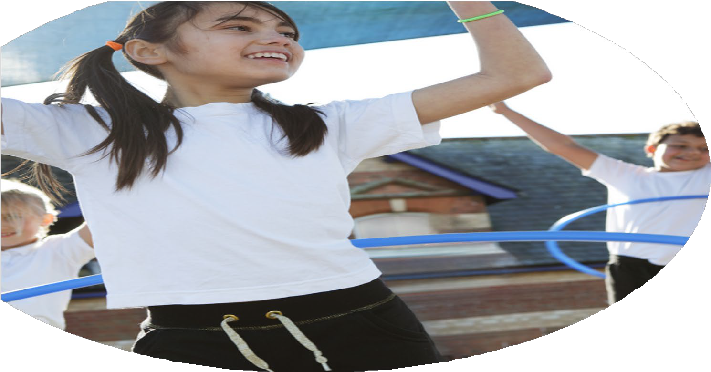

Evaluation Form

**Commissioned by**

**Created by**

Images courtesy of Youth Sport Trust

**PE Funding Evaluation Form**

 It is intended that this template should be used as preparation for the completion of the statutory digital reporting tool being introduced this academic year. You can upload data (including swimming) from this template onto this platform once it becomes accessible.

 Before you decide how you are going to use the funding for this academic year you should reflect and evaluate the impact of your use of the funding in 2023/24.

 All spending of the funding must conform with the terms outlined in the Conditions of Grant document.  The template is a working document that you can amend/update during the year.

 Based on your evaluation of last year’s funding you should decide what you intend to do this academic year, how you will do it, and what impact you expect it to have.

It is important that the funding is used effectively and based on your school’s needs.

 You must use the funding to make additional and sustainable improvements to the PE and sport in your school.  You must develop and add to the PESSPA activities that your school already offers.

*Summative digital reporting from June 2025 will continue to include swimming and water safety information therefore funding can be used to provide top-up lessons where necessary to ensure pupils meet national curriculum swimming requirements.*

**We recommend that you start by reflecting on the impact of current provision and reviewing your previous spend**

|  |  |  |  |
| --- | --- | --- | --- |
| What went well? | How do you know? | What didn’t go well? | How do you know? |
| All children to understand the importance for physical activities and the impact this has on our physical and mental health.  Profile raised with the appointment of a new PE Lead.  To equip staff with a bank of games and activities they can deliver with confidence and fit into their daily timetable.  Provide pupils with opportunities to engage in a range of sports  Pupil's to take part in competitive sports in and out of school. | Linking physical education to emotional health and well-being during whole school well-being day workshops every half term.  CPD Shared with whole school staff  Mini leaders supporting sports at lunchtimes  Regular monitoring every half term  First Grade Sports up to date with assessment following assessment Matrix and Progression Documents in line with specific planning  Improved data from the 1-4 assessment framework  All teachers given a bank on ideas and an activity list.  All teachers signed up to a daily activity slot.  Pupils offered a broad range of sports and activities  Pupil premium unlimited access to sporting experiences  SEND opportunites for sports related activities alongside peers with similar needs across Erewash  Pupil's understand the importance of working as a team  Communication and working with a range of peers  Understanding how to take part  Personal best  Costs  Weekly cost for FGS x 4 days a week Resources and equipment needed £12000  £200 CPD For PLT Teacher cover - Supply | More access to a range of greater competitive events with other schools  OAA opportunities for pupils planned into the curriculum  A well sequenced curriculum of PE | We attended many events but there is a lack of league for schools to access for team sports such as football  OAA not coherently planned in the curriculum  The PE curriculum was not well sequenced to ensure progressive delivery of key knowledge |

|  |  |
| --- | --- |
| What are your plans for 2024/25? | How are you going to action and achieve these plans? |
| Intent | Implementation |
| KI 1 Increased confidence, knowledge and skills of all staff in teaching PE and sport   * Working in conjunction with First Grade Sports to provide a progressive PE Curriculum to all pupils 4 afternoons a week.   KI 2 Engagement of all pupils in regular physical activity  KI 4 Broader experience of a range of sports and activities offered to all pupils   * Increase physical exercise in school * Wide range of clubs and sports embedded in the curriculum   KI3 The profile of PE and sport is raised across the school as a tool for whole school improvement  KI5 Increased participation in competitive sport   * Raise profile of PE for pupils * Continue to establish Whole School Travel SMART awareness and Engagement * Establish more opportunities to take part in competitive sports * Swimming to be delivered to y5 and 6 with effective CPD fpr staff in wave awards * Plan and deliver a more progressive curriculum with OAA clearly defined * Work with Enrich to establish OAA in school | CPD for teachers and taking part in wider community sports  Newly planned and sequences curriculum.  More PE to be taught in our curriculum  Work with other schools to establish matches for competitive team games  Sports champions engagement  Swimming CPD for key staff through S4S  Enrich to install OAA course within school grounds and staff CPD to be shared. |

|  |  |
| --- | --- |
| What impact/intended impact/sustainability are you  expecting? | How will you know? What **evidence** do you have or  expect to have? |
| Broader experience of a range of sports and activities offered to all pupils.  Increased participation in competitive sport work with other local schools to plan matches  Increase in pupils reaching the swimming standard by year 6 using the wave awards for accurate progression and assessment  Increased profile of sports within school.  Higher confidence of staff in assessment and teaching the curriculum based on effective use of key component knowledge to be taught in each lesson and how this feeds into the next to support pupils in remembering more and doing more. | Primary teachers are more confident to deliver effective PE supporting pupils to undertake extra activities inside and outside of school, including teaching water safety and swimming and as a result improved % of pupil’s attainment in PE.  Bikeability has taken place and has had a positive effect. Improvements: Ensuring all parents are aware of the costings, timings and resources required/involved  More pupils meeting their daily physical activity goal, more pupils encouraged to take part in PE and Sport Activities.  A range of pupils have accessed active after school club opportunities Pupil Premium children are given priority.  Clubs will continue with a strong focus on sporting activities. We will also introduce lunch time clubs to offer the more chances to those pupils who cannot attend after school clubs.  We will develop the Pe curriculum further by redesigning our curriculum to ensure more PE is taught and utilizing Get set for PE to structure units and lessons to ensure learning is built upon progressively. Teachers will also be provided with support in developing their own understanding of delivering effective PE provision through the support of FSG and GS4PE. |

|  |  |
| --- | --- |
| What **impact/sustainability** have you seen? | What **evidence** do you have? |
| Staff are more confident in teaching and assessing PE  Pupils are remembering more and doing more.  Progression is visible in the curriculum  OAA Is being taught discretely  Pupils are engaging in a wider range of sports. | Teachers show that they are following curriculum maps correctly and have expressed there enjoyment of engaging more with PE teaching. Staff have attended relevant CPD and will engage in more in January 25.  Teaching is matched to progression documents to ensure that pupils are being taught in logical small steps. This is also carried out by our external coaches who teach our curriculum.  Our curriculum scope check shows that we have assessed our curriculum against the national curriculum and ensured that OAA is taught and planned into our curriculum. This has been enhanced by an activity day delivered by an external provider based on developing OAA skills. We are also engaging with Enrich to ensure that OAA is delivered effectively through an installation of OAA courses on the school grounds planned for Sept 25.  Cost of OAA day- £620.00  Cost of potential OAA course installation £2500  Clubs show a healthy uptake and sports such as golf, rugby football and hockey are offered. |